Compound of is compound :- people – data – hw – sw – network

Compound of dss compound :- data –model – knowledge – interface – user

characteristics of is system :

Organise Data into information

Analysis of Information to give knowledge Make a list of as many information systemsthat you can think of

Characteristics of dss system

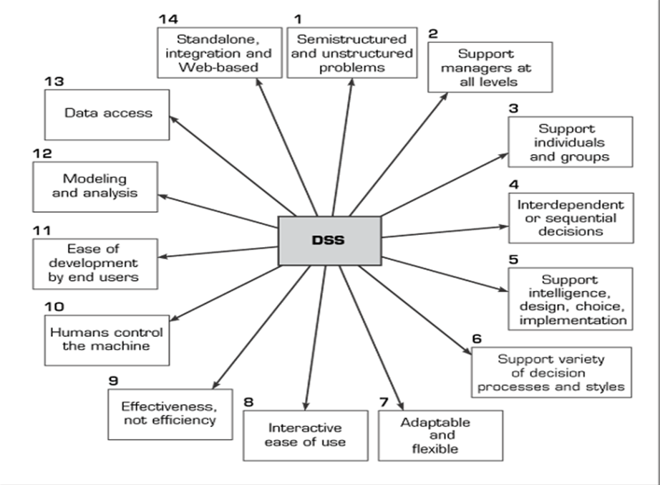

***********Bs aktbehm msh mn alrsma

Importance of is system :-

**1-To Control The Creation and Growth of Records.**

2-**To Reduce Operating Costs**

**3-To Improve Efficiency and Productivity.**

**Importance of dss :**

**1-Analysis data to help manger in taking descion**

**2- combine modeling with user experience**